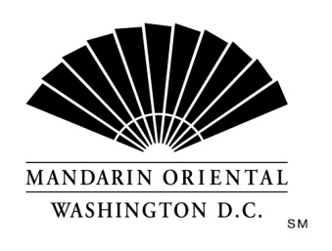
JOB DESCRIPTION
Position: Back Server-Muze Restaurant
Department: Muze
Reports to: Food & Beverage Manager

The Company
Mandarin Oriental Hotel Group is the award-winning owner and operator of some of the world’s most prestigious hotels and resorts. The Group now operates or has underdevelopment over 40 hotels with more than 11,000 rooms in 25 countries in key business and leisure destinations.

The Hotel
Our award winning property, in the nation's capital, is situated on D.C.'s growing South West waterfront. Commanding monumental views, the property offers 400 guest rooms including 54 suites, extensive event space, and our Forbes Four Star Rated Spa at Mandarin Oriental. Mandarin Oriental, Washington D.C. welcomes individuals who are guest centered and are committed to making a difference every day; continually getting better to keep us the best.
Mandarin Oriental, Washington, D.C. is currently seeking an experienced food and beverage professional for our open back server position in our all day dining outlet, Muze Restaurant. This is a full time position that requires a very flexible schedule with the ability to work a mixture of AM & PM shifts.
The Back Server will be assisting the Front Server and will be responsible for creating a pleasant dining environment and experience for guests. Will maintain all dining room environment and equipment clean and tidy, assist guests with questions about the dinner menus/wine list, and anticipates guests' needs and address them accordingly.
Job Requirements
- Minimum of 1 year food & beverage service experience is required in an upscale establishment or hotel setting.
- High school diploma or equivalent is required.
- Fluency in English (both written and verbal) is required with excellent communication skills.
- Must be able to work a very flexible schedule that will include early mornings, late nights, weekends and holidays.
- Must be able to physically perform duties associated with this position such as: standing/walking for extended periods of time; able to lift/pull/carry/push up to 40 lb. boxes, carts, cases, trays, etc.
- Must be familiar with common food and beverage terminology and be familiar with various cooking techniques; prior experience with wines, specialty cocktails, craft beers, etc. strongly preferred.
- Prior experience working in a union environment preferred.
- Prior luxury hotel experience strongly preferred.
- Bi-lingual abilities preferred.

Each of the items listed is considered an essential function of the position. However, the duties, responsibilities and requirements presented in this job description are intended to be broad based and high level and should not be construed as an exhaustive list of all roles or responsibilities for the position. The Company reserves the right to alter the duties and responsibilities of the position.
It is Company policy to comply with the Americans with Disabilities act, including by providing reasonable accommodations that do not constitute an undue hardship on the Company. Employees or applicants should direct requests for accommodation to Director of Human Resources.

