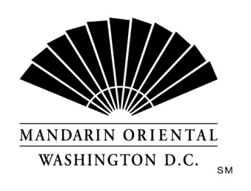
JOB DESCRIPTION
Position: Empress Lounge Bartender
Department: Empress Lounge
Reports to: Food & Beverage Manager

The Company
Mandarin Oriental Hotel Group is the award-winning owner and operator of some of the world’s most prestigious hotels and resorts. The Group now operates or has underdevelopment over 40 hotels with more than 11,000 rooms in 25 countries in key business and leisure destinations.

The Hotel
Our award winning property, in the nation's capital, is situated on D.C.'s growing South West waterfront. Commanding monumental views, the property offers 400 guest rooms including 54 suites, extensive event space, and our Forbes Four Star Rated Spa at Mandarin Oriental. Mandarin Oriental, Washington D.C. welcomes individuals who are guest centered and are committed to making a difference every day; continually getting better to keep us the best.
Mandarin Oriental, Washington, D.C. is currently seeking a full time bartender to join our dynamic Empress Lounge team!
The bartender will provide superior service to our valued guests, ensuring their delight with unique food and beverage offerings. The ideal candidate will have prior bartending experience in an upscale or luxury setting, with a deep and varied knowledge of cocktails, beers, wines and various liquors. The bartender will be able to complement the guest's food selections with advice on proper beverage pairing; providing stellar service and attention to detail with every interaction. We are looking for someone who is passionate about guest service, an individual who is ready to anticipate and exceed expectations on a daily basis.
Requirements
- 2 years of bartending experience is required; those with volume experience are preferred.
- Must possess certification as a bartender (professional bartending certification, TIPS, ServSafe preferred).
- Prior experience in a luxury or upscale hotel/restaurant preferred.
- Must be able to work a flexible schedule to include both AM and PM shifts, late nights, weekends, and holidays.
- Demonstrated multi-tasker with a positive attitude.
- Fluency in English is required (both written and verbal) with excellent communication skills.
- Prior MICROS experience strongly preferred.

Each of the items listed is considered an essential function of the position. However, the duties, responsibilities and requirements presented in this job description are intended to be broad based and high level and should not be construed as an exhaustive list of all roles or responsibilities for the position. The Company reserves the right to alter the duties and responsibilities of the position.
It is Company policy to comply with the Americans with Disabilities act, including by providing reasonable accommodations that do not constitute an undue hardship on the Company. Employees or applicants should direct requests for accommodation to Director of Human Resources.

Signature

Applicant
I have reviewed this job description and have asked any questions necessary to understand its content.
________________________________________________________ _______________________
Applicant Date
Human Resources
I have presented this job description to the above named applicant.
________________________________________________________ _______________________
Human Resources Representative Date

