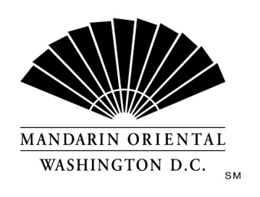

The Company
Mandarin Oriental Hotel Group is the award-winning owner and operator of some of the world’s most prestigious hotels and resorts. The Group now operates or has underdevelopment over 40 hotels with more than 11,000 rooms in 25 countries in key business and leisure destinations.

The Hotel
Our award winning property, in the nation's capital, is situated on D.C.'s growing South West waterfront. Commanding monumental views, the property offers 400 guest rooms including 54 suites, extensive event space, and our Forbes Four Star Rated Spa at Mandarin Oriental. Mandarin Oriental, Washington D.C. welcomes individuals who are guest centered and are committed to making a difference every day; continually getting better to keep us the best.
Mandarin Oriental, Washington D.C. is currently seeking an Assistant Manager for our Front Office department.
Duties and Responsibilities
- Ensure a delightful, seamless arrival and departure experience by adhering to our Legendary Quality Experiences
- Handle all guest compliments, comments, and observations in a timely and effective manner thereby achieving complete guest satisfaction
- Communicate all guest compliments, comments, observations to relevant departments and ensuring follow up
- Process guest charges and payments accurately
- Ensure the proactive building of guest history and guest preferences
- Ensure accurate communication of information and guest requests by Front of House team members
- Coach Front Office team members to deliver highly personalized and genuine service to both internal and external guests
- Act as Manager on Duty as assigned
- Other duties as assigned by the Front Office Manager and Director of Front Office.
Requirements
- 1+ year of supervisory/management experience in front office operations at a luxury hotel/resort property.
- Excellent communication skills with fluency in English required.
- Ability to work a very flexible schedule which will include early mornings, late nights, overnights, weekends and holidays.
- Computer proficiency to include: MS Office, Excel, Word, PowerPoint, Springer Miller Systems, MICROS.
- Superior guest resolution and problem solving abilities are required.
- Bachelor's Degree in related field is required; a combination of education and direct related experience will be considered in lieu of a Bachelor's Degree.

Each of the items listed is considered an essential function of the position. However, the duties, responsibilities and requirements presented in this job description are intended to be broad based and high level and should not be construed as an exhaustive list of all roles or responsibilities for the position. The Company reserves the right to alter the duties and responsibilities of the position.
It is Company policy to comply with the Americans with Disabilities act, including by providing reasonable accommodations that do not constitute an undue hardship on the Company. Employees or applicants should direct requests for accommodation to Director of Human Resources.

